

“An Investigation into deployment tools to determine the futuristic requirements for business standards”

BY

Kirsty Marjory Forrest

1501752

A Research Project submitted in fulfilment of the requirements for the award of BSc (Hons) Computer Science with Placement.

Word Count: 14,361

May 2020

Contents

Declaration 3

1. Acknowledgements 3

2. Abstract 3

3. Introduction 4

4. Requirements of the Project 4

4.1 Methodology Design 4

4.2 Functional Requirements 4

4.3 Non-Functional Requirements 5

4.4 Project Constraints 5

4.5 Software 6

4.6 Network Topology 6

4.7 Physical Device 6

4.9 Test Scenarios 6

4.10 MoSCoW 7

5. Literature Review 8

5.1 Introduction 8

5.2 Background 8

5.3 SCCM 10

5.4 Intune 10

5.5 Group Policy with Intune 12

5.6 Mobile devices 12

5.7 Smart Deploy 12

5.8 Benefits and Weaknesses 12

5.9 Comparison of Methods 13

5.10 Workspace One 14

5.11 Centralized Network 14

5.11 Problems in Large-Scale Deployments 14

5.12 Azure 15

5.13 Virtual Machines 17

5.13.1 Virtual vs Physical 17

5.14 Raspberry Pi 18

5.15 ISO Files 18

5.16 Servers 19

5.16.1 Linux 19

5.16.2 Debian and Ubuntu 20

6. Design of Raspberry Pi 20

6.1. Design Diagram 20

6.1.2 Conceptual Design 22

7. Implementation of the Raspberry Pi 23

Pre-installation 23

Installation 23

Testing 25

8. Testing and Results 25

8.1 Requirements Testing 25

Test Cases - Tables 26

Test Cases - Tables 26

8.2 Questionnaire 28

8.3 Test Evaluation 29

9. Evaluation 29

10. Conclusion 31

11. Appendix 32

11.1 Links 32

11.2 Project Proposal 32

Project Title 32

Background 32

Motivation 33

Aims and Objectives 33

Legal, Social, Ethical, Professional and Security Issues 33

Project Plan 34

11.3 Poster 35

11.4 Demo Screenshots 36

11.4 Abbreviations 41

11.5 Source Code 41

11.6 Test Plans 41

11.7 Project Log 41

11.8 Ethics Policy Application 41

12. References 45

# Declaration

I confirm that the work contained in this Honours project report has been composed solely by myself and has not been accepted in any previous application for a degree. All sources of information have been specifically acknowledged and all verbatim extracts are distinguished by quotation marks.

Signed: Kirsty Forrest, Date: 18/05/2020

# Acknowledgements

I would like to dedicate this section to appreciate those who have kept me strong and motivated throughout the past five years.

I would like to thank my mum, Fiona for her continuous emotional support throughout my further education. To always being there to read and grammatically check a report.

I would like to thank my partner, Jack. Battling through the challenges together. Managing to survive through Brexit and Coronavirus.

I would like to thank all my close friends, Alison, Amy and Jasmine for their support on stressful days and having my back 24/7 for midnight chats.

I would like to thank the lecturers of Moray College, Elgin and the staff in CSDM, RGU for their care and support throughout the past six challenging years.

I would like to acknowledge Andrei Petrovski for all his hard work throughout this project, who guided me through the entire process. Providing critical views, ideas and feedback.

Finally, I would like to thank Tom, Marc, Phil and Lucille at RockRose Energy. Working with you for the past three years has been the at most pleasure. Thank you for pushing me to my limits throughout projects. The inspiration and the general idea came from working within the End User Computing team.

# Abstract

Each machine we touch, has been a part of a deployment process. Some appear more complex than others. This could be from something very simple such as opening a fresh copy of Windows to starting a new job with a new laptop. The process is so complex. It can be difficult and challenging for non-technical background user to understand. The industry is dominated by a few giants who set the industry standards. Microsoft, the creator of Windows has the largest share in machines. The company developed and produced software to manage these devices within a corporate environment. Having such a large market share allows them ultimately to influence how the market reacts.

# Introduction

The project I have chosen involves investigating deployment methods within a business environment. Deployment methods have been around since the beginning of machines. They began very basically with simple installations of software on each machine individually to progressing towards the creation of more sophisticated .iso files on a bootable machine necessary to meet the needs of today’s deployment methods.

Throughout this process, I identified a flaw within the system when creating a machine with core images and applications. Most deployment methods do not offer a low bandwidth option, but more importantly if there is no technical expertise available. Often technical support can be in a different country or remote. Potentially this could determine the futuristic element of the project by the means of reviewing the regular methods and how they could improve and produce cost-saving features to a business.

The aim of this project is to investigate deployment tools and determine if the requirements they provide are adequate for the future needs of businesses standards. The tools will be critically evaluated on their effectiveness for determining the futuristic values of a corporate environment. The project also investigates alternative methods of deployments including a Raspberry Pi.

# Requirements of the Project

## Methodology Design

In this section, I will discuss the functional and non-functional, physical and virtual requirements of the project. The network topology will detail the devices and how they interconnect together. A home network or lab will be set up with a Raspberry Pi as a deployment server with a screen on the Pi to act as a multi-optional operating system. Also, server management improvements will be attempted to make it as powerful as possible. The experiment has two Raspberry Pi’s: Server and Client. The current solution for most businesses is the machine is disconnected and couriered to the nearest technical support area to be fixed or troubleshoot the device. The Raspberry Pi has been used to deploy to the workstation. Raspberry Pi has allowed for the operating system to be chosen and it will configure the machine. The device is simple to use, and it provides easy instructions to follow.

## 4.2 Functional Requirements

* Raspberry Pi’s
  + Raspbian-Linux – Client
  + Raspbian-Linux – Server
* 1 x Physical Machine for development
  + The machine used for the development of the server and the main configuration screen for Raspberry Pi
* Linux Server ISO File
  + Required for the deployment of the Linux Image
* Linux Server Software
  + This acts as a deployment server, hosting the image of the deployment images and any applications. The server is holding the ISO and application files for deploying from the Raspberry Pi to the machine.
  + The server is reliable and stable. It does not crash during deployments as this could cause the deployment to crash and be unusable and break the machine.
  + Attempts have been made to improve the functionality of server management.
* Raspberry Pi and Accessories
  + Raspberry Pi Display
    - The screen on the Raspberry Pi demonstrates a display to the user giving them an idea of what is being deployed onto the machine
    - The display shows the possible options depending on which type of user is logged into the device; user/client, admin or global admin
  + The Raspberry Pi will deploy the chosen operating system onto a physical device
  + The Raspberry Pi should not use any network connections to deploy Operating System or Applications once configured. This is to ensure it could be used as in low bandwidth or non-existent area.

## 4.3 Non-Functional Requirements

* Disaster Recovery Plan
  + A plan for managing hardware failure
  + How backups of the deployment will be managed
* Data Protection Plan
  + Protecting the data stored on the local machine
  + Protecting the data belonging to the user
* Ensuring software and operating system updates are applied
  + Check for regular patching
* The project must be delivered by 18th May 2020
  + Deadline of Coursework Submission date
* The project must be created using Python, Windows, Linux, Debian, and Ubuntu
* All code and command-line script should be commented
* Security measures to ensure data on the machine before deployment is gone successfully before overwriting.
  + Use a system like Kill Disk before deploying if personal data is found on the machine
* Security measures to ensure the deployment server is secure.
  + Checking for updates, no vulnerabilities on network and secure networks are used
* Security measures to make sure any data supplied or entered is correctly managed under GDPR.
* The project will run Linux based systems
* The prototype was created by end of January 2020 as a proof of concept
  + Deployment method was implemented in an agile process
  + User responses to be collected and improvements made to the project at milestones.
  + User responses should be kept correctly under guidelines of data protection
  + Project Supervisor to be updated weekly via meetings and Asana (used to track the progress of the project).

## 4.4 Project Constraints

* Time constraints
* Access to University equipment and lab space for development
* Memory in SD Cards in Raspberry Pi. A large amount of memory will be required for the ISO and application files
* Ever-increasing scope
* Data compliance
* Coronavirus

## 4.5 Software

* VMWare
* Windows Server
* Linux Server
* Python

## 4.6 Network Topology

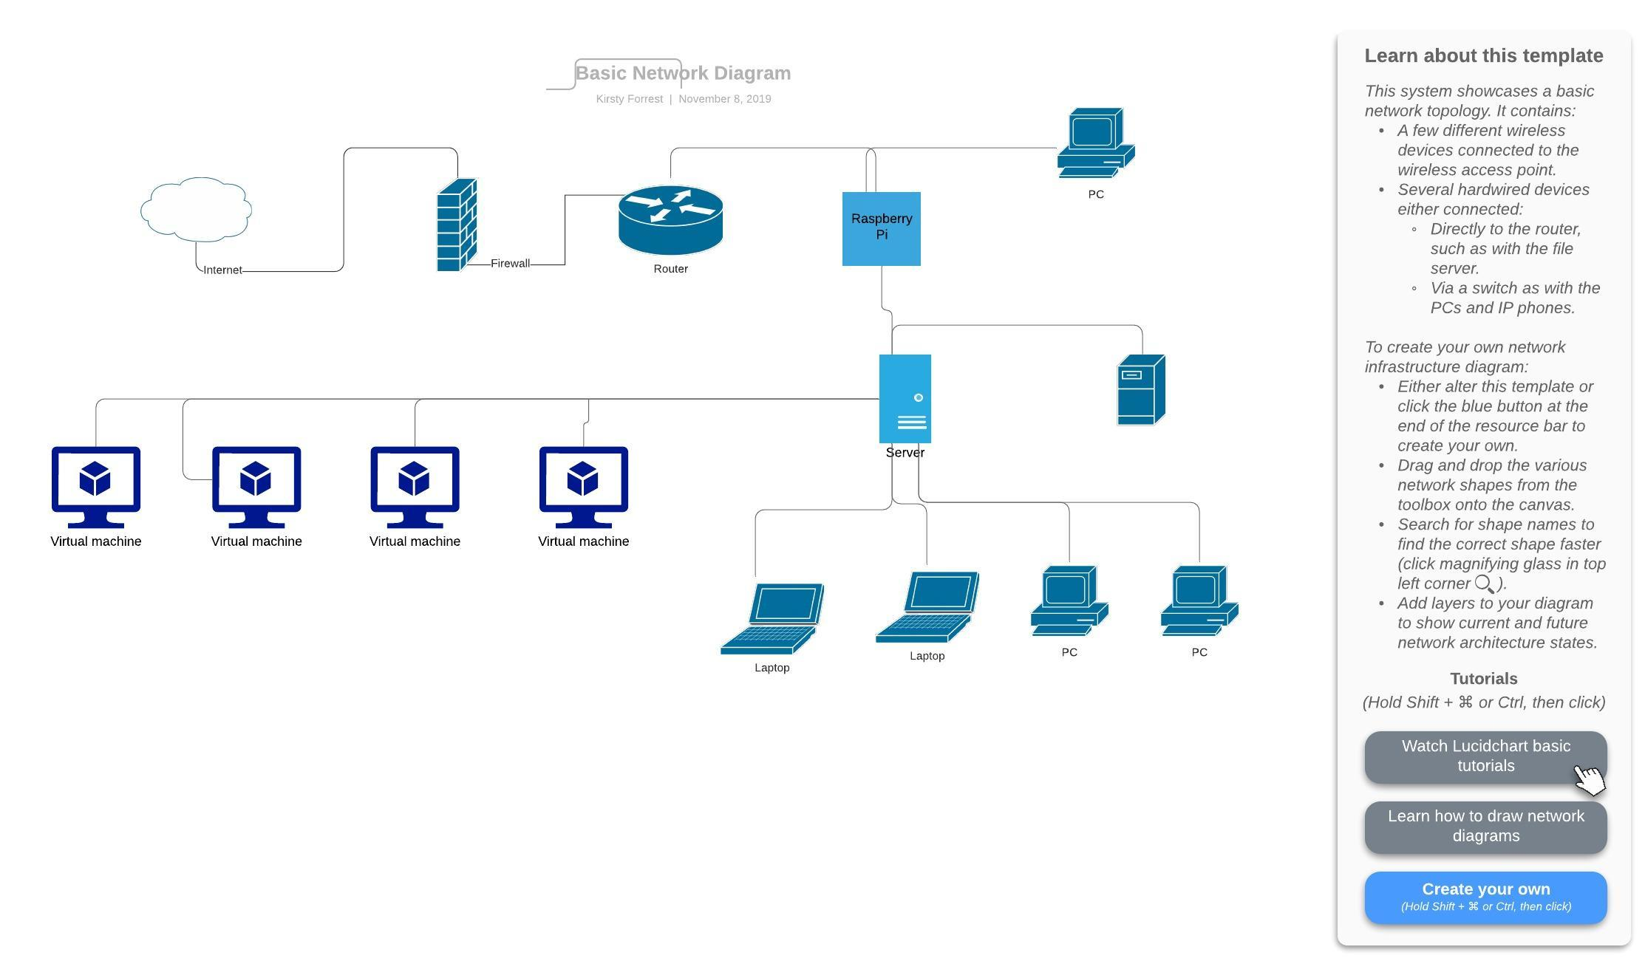

[Figure 1]. This was the ideal network topology. Throughout this project, it has been simplified due to the changes in the project scope.

## 4.7 Physical Device

The table below details the physical devices that were used throughout this project.

|  |  |
| --- | --- |
| Devices | Specifications |
| PC-D (Development Machine) | 8.00 GB RAM, 64 bit Microsoft, Windows 10 Processor: Intel Core i7 |
| Raspberry Pi - Server | 1.5 Ghz, 64-bit Quad Core CPU, 4GB RAM, 2 x USB 3.0, 2 x USB 2.0, 2 x micro HDMI ports |
| Raspberry Pi – Client | 1.5 Ghz, 64-bit Quad Core CPU, 4GB RAM, 2 x USB 3.0, 2 x USB 2.0, 2 x micro HDMI ports |

## Test Scenarios

To understand the effectiveness of using a Raspberry Pi as a deployment method. These tests show an outline of network performance.

Test Cases:

1. Raspberry Pi loads Pi Screen
2. PXE Installs ISO
3. PXE Server shows multiple options for selections
4. Raspberry Pi can boot physical machine with ISO
5. Selection choice on Raspberry Pi screen for the target machine has a multi-choice box that allows a custom-built image created
6. Selection choice on Raspberry Pi Screen for target machine has a custom built-in core image for the machine
7. A technical person is given the Raspberry Pi to boot and build the machine. Tests machine for basic functionality from the given list
8. Non- technical person is given the Raspberry Pi to boot and build the machine. Tests for basic functionality from a given list
9. Perform a deployment in a remote location

## 4.10 MoSCoW

The table represents the features that must have, should have, could have and will not be implemented within the projects scope.

|  |  |  |  |
| --- | --- | --- | --- |
| Must-Have | Should have | Could have | Will not have |
| Raspberry Pi loads Pi Screen | Raspberry Pi shows multiple options | Create a box that allows a custom image to be built | A Microsoft or other vendor software used to deploy the workstations except for Server |
| PXE Installs basic ISO | Shows Multiple ISO Files | The script runs on the target machine that shows network performance and application | It will not include file storage unless required for storage of ISO and application files |
| Raspberry Pi can boot to Physical Devices | The script that shows network performance | Custom created a multi-option choice box for custom-built | Multiple languages for the display. The language will only be ‘English UK’ |
| A technical person, who has University level experience or knowledge in a computer science background is given the Raspberry Pi to build and test the functionality | Error Free as much as possible |  | The visual interface will not be extremely visually pleasing, it will be simple and basic |
| A non-technical person, who has no technical knowledge is given the Raspberry Pi to build and test the functionality of what the device does | The interface is easy to navigate |  |  |

[Figure 2]

# Literature Review

## 5.1 Introduction

The literature review was selected to assist me to critically analyse what kind of tools can be used and will be key to the future of business deployments. The resources used helped me understand the essential process necessary to create a deployment server which would be used by central admin services. The review will investigate tools such as SCCM, Intune and Smart Deploy along with using technology such-as Raspberry Pi’s.

## 5.2 Background

Deployment methods have been around since computers began. The main purpose of why they exist remains similar to today’s requirements. System Centre Configuration Manager, more commonly known as SCCM, is Microsoft’s largest and oldest method of deployments. It is needed to “manage the deployment and security of devices and applications”. (“Microsoft Windows Intune versus System Center Configuration Manager | Communication Square LLC” 2020). SCCM is used for the deployment of devices. It is the most popular to use but it has its challenges which will be discussed in this review. By comparison Intune is a cloud-based system that can be used in deployment whereas SCCM is not. The main purpose is not solely deployments, it is also mobile management, but could this be the future of deployment methods? “Microsoft Intune is a cloud-based service” (“Microsoft Windows Intune versus System Center Configuration Manager | Communication Square LLC” 2020).

Previously, SCCM and Intune have been used side by side to complement each other’s features but recently there has been a move to solely implement an Intune solution. SCCM can be challenging to grasp and configure unless the admin is experienced in using similar deployment tools enabling some advantages for easier deployment (“Microsoft Windows Intune versus System Center Configuration Manager | Communication Square LLC” 2020)

“A virtual machine is a computer file, typically called an image, that behaves like an actual computer” (“Microsoft Windows Intune versus System Center Configuration Manager | Communication Square LLC” 2020). It runs a machine on an existing machine, often running a different type of operating system; Windows 7 or Linux. The virtual machine is often essential to development work as work can be saved at a state and reverted towards if testing was to fail or required backwards transition. (“Microsoft Windows Intune versus System Center Configuration Manager | Communication Square LLC” 2020)

“Mobile Device Management is a software application used for managing endpoints”. MDM is a tool used for devices such as laptops and smartphones. Being a mobile device tool, the primary focus was the management of these devices. The tool can be used for gathering details, locating and most importantly securing the device. The device can be wiped on request if stolen or lost. (“Microsoft Windows Intune versus System Center Configuration Manager | Communication Square LLC” 2020)

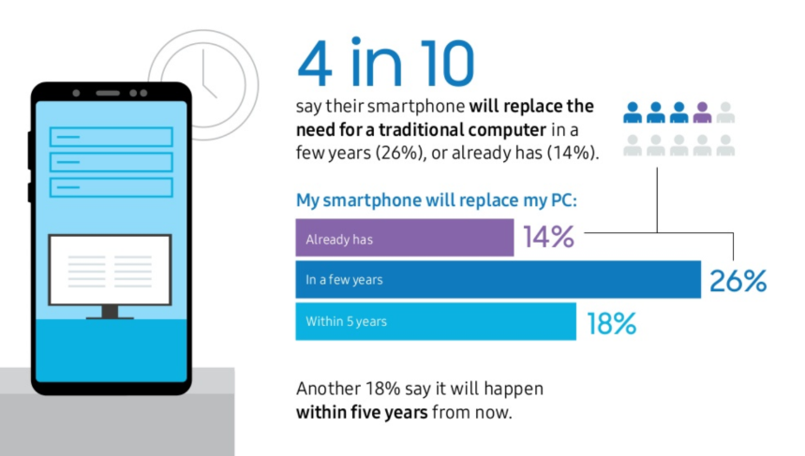

Figure 3: ManageEngine: (“[SOLVED] SCCM or Intune? - Microsoft Intune - Spiceworks” 2020)

According to ManageEngine, mobile device users have already started the transition away from having a workstation. A simple example of this is, a university student only carrying an iPad around campus. This more compact device offers the same functionality as a standard laptop. The requirements are a basic office package. Although the move to mobile devices offers vast benefits risks remain around unauthorized access along with data leaks if a device is left vulnerable by not patching.

“UEM refers to a new class of tools that can act as a single management interface for mobile, PC and other devices”.(“Microsoft Windows Intune versus System Center Configuration Manager | Communication Square LLC” 2020). UEM encloses all the surrounded tools and management suites to ensure the configuration is managed under one system. (“[SOLVED] SCCM or Intune? - Microsoft Intune - Spiceworks” 2020)

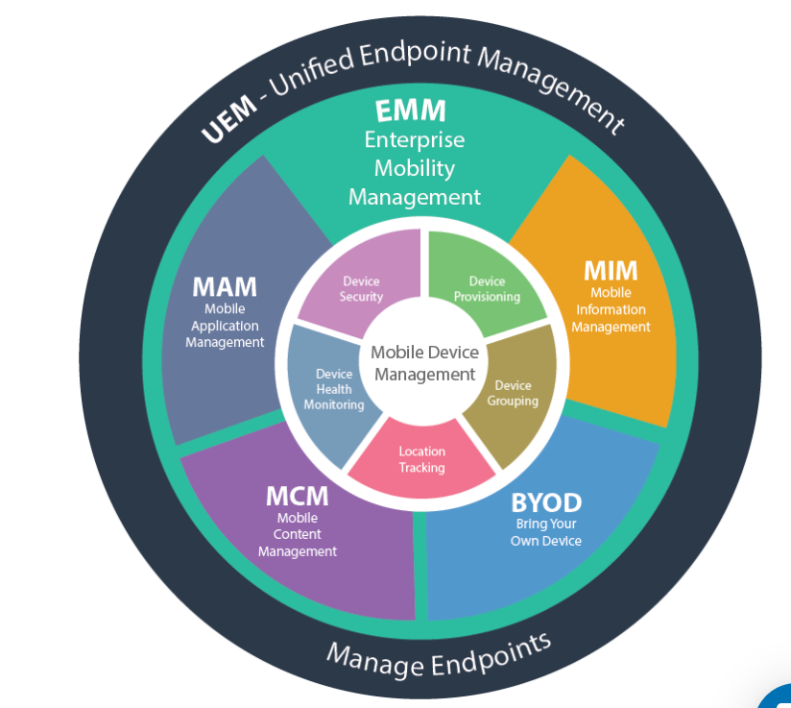

Figure 4: Management of Endpoints: (“Microsoft Windows Intune versus System Center Configuration Manager | Communication Square LLC” 2020)

## 5.3 SCCM

Microsoft System Centre Configuration is a well-established product in the Microsoft fleet of software. System admins are provided with a console to manage their environment. Physical and virtual machines are managed together to control the network infrastructure. Active Directory (AD) is necessary for the management of people, computers, and groups. On each machine, a background process is placed. This sends feedback to the console notifying the admins of changes, vulnerabilities, and risks on the network. Although this is important, a product of the future demands more than notifications, to act and to patch vulnerable systems. (“[SOLVED] SCCM or Intune? - Microsoft Intune - Spiceworks” 2020).

## 5.4 Intune

Intune was first created in 2010, where it was established as a tool to manage Windows XP and Windows 7 from the cloud. The system was designed with the view of the machine being connected to the network. Portable machines were not included this early on due to the technology for laptops and portable devices not commonly in use. Microsoft discovered that businesses were moving away from desktop machines in an enterprise environment. They needed to combine the efforts made by iOS, therefore they developed “mobile device management with Exchange ActiveSync (EAS)”. This created the framework of InTune we still see today which allows us to “manage both mobile devices and PC’s from the cloud”.

Due to the vast quantity of machines already having SCCM installed, Intune was use side by side to integrate features such as “cloud management into the Configuration Manager service” (“Microsoft Windows Intune versus System Center Configuration Manager | Communication Square LLC” 2020). But after a period, Microsoft decided Intune should be used as a standalone solution for a cloud environment for mobile. “SCCM client simply cannot be installed onto them (such as an Android or iOS)”. Having no way to install the SCCM installer on these devices caused problems, this problem still exists today. Intune attempts to resolve it by creating an application that can be installed from the device's application store or windows store for tablets. The transition away from SCCM was due to the design fundamentals of the product. (“[SOLVED] SCCM or Intune? - Microsoft Intune - Spiceworks” 2020)

Today, Intune has been developed into a vast and greater sized solution, competing directly with SCCM for market coverage. “Enterprise mobility + Security” more commonly known as EMS includes the device and app management, identity and access management and protection-based data. These are just some of the functionality the tool has.

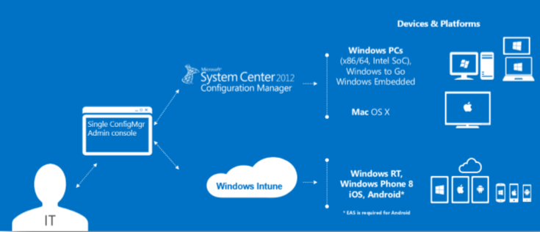

Figure 5: Intune with combined SCCM, Reference [Dec2012_Windows_Intune_Getting_Started]

The diagram above shows the breakdown of a typical Intune and SCCM deployment. The diagram shows the direction in which IT department should manage the administrative side of the service, they communicate directly with the configuration console which in turn communicates with the Intune cloud service along with the SCCM configuration and installation of the business’s machines. Both spin-offs to include the devices each service support. This is the classic style of managing devices.

The second method of managing Intune is solely using the Intune cloud-based implementation where SCCM is removed from the graph and both PC’s and mobile devices would be controlled by Intune.

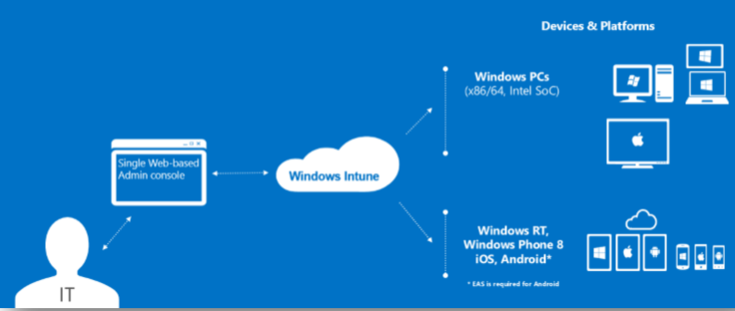

Figure 6: Cloud Based Intune Setup [Dec-2012_Windows_Intune_Getting_Started]

## 5.5 Group Policy with Intune

Intune is often compared to group policy updates and can be questioned if it can be replaced. “Microsoft Intune also has a set of policies, even policies that are duplicative of Group Policy”. Most policies can be applied on Intune, but TechNet advises “not all Group Policies are available via MDM”.The functionality of Intune may not be there currently, but in the future, this may hold where group policy is redundant as Intune implements more group policy friendly features. A lot of new features would need to be created and the functionality to create new policies that didn’t previously exist. The technology is available. (“Microsoft Windows Intune versus System Center Configuration Manager | Communication Square LLC” 2020)

## 5.6 Mobile devices

To manage your devices in a Microsoft environment, you are given two clear options: Intune and Mobile Device Management for Office 365. MDM is included in the commercial subscriptions which itself carries a cost of the subscription per month/year. This varies from the number of required products. Intune requires a paid subscription for Intune which includes the mobile device management tools. Both require a cost involved for management. (“[SOLVED] SCCM or Intune? - Microsoft Intune - Spiceworks” 2020)

Intune is managed by using the “Intune admin console” (“Microsoft Windows Intune versus System Center Configuration Manager | Communication Square LLC” 2020)which is provided as part of the package, this includes “iOS, Mac OS X, Android, Android Enterprise, Windows 8.1 and 10” (“[SOLVED] SCCM or Intune? - Microsoft Intune - Spiceworks” 2020). There is a vast list of devices that can be controlled, and features applied to whereas Office 365 package only applies to “iOS, Android and Windows Devices” (“Microsoft Intune” 2020). However, it does not work on Mac OS X and Android Enterprise. This list is much shorter and restrictive to the type of devices that may be included in a smaller organisation which cannot buy the more expensive devices. The devices in O365 are also cloud-based management in the O365 portal. Intune delivers a more extensive list and availability to organisations is better.

## 5.7 Smart Deploy

Although Microsoft products hold a large sector of the software and operating system deployments, there are smaller tools that are breaking through the market. Caperra defines SmartDeploy as “leading provider of modern endpoint management solutions”. They offer solutions for machines from 50-50,000, it could compete directly with SCCM and Intune who distribute the same number of machines. (“Microsoft Windows Intune versus System Center Configuration Manager | Communication Square LLC” 2020).

## 5.8 Benefits and Weaknesses

A review created on Capterra from a user-described issue that occurred whilst he was using SmartDeploy “you have to walk them through installing the enterprise software which I don't necessarily want them to have access to”. This is a critical feature for most businesses, especially oil and gas where they will have users who will be responsible for communication and basic IT knowledge upon platforms. The installations should be done by a central team, to ensure a standard across all deployments (“[SOLVED] SCCM or Intune? - Microsoft Intune - Spiceworks” 2020).

“Unintuitive and difficult to learn and sustain”. (“Microsoft Intune” 2020). Deployment usually requires extensive knowledge training to understand the system. SmartDeploy uses “how-to video combined with guided wizards”. This makes training and the skill level required for managing the operating system can be passed and taught to many. (“Microsoft Windows Intune versus System Center Configuration Manager | Communication Square LLC” 2020)

SmartDeploy can be set up and installed quickly. It allows for a trial basis that SCCM and Intune do not. The overall cost of the tool is per machine, with a company with 400 machines total would cost $6,325.00 ($23.30 per machine, £4,901.97 in total) for the tool. This is using the basic model of the tool which covers a variety of features from Asset Management and Application Deployment. To gather an estimate of SCCM cost to compare, a Microsoft partner would be required to gather requirements on the build and deployment of the software. (“[SOLVED] SCCM or Intune? - Microsoft Intune - Spiceworks” 2020).

## 5.9 Comparison of Methods

The table below shows the contrasting and comparative details of each of the deployment tools. It details the characteristics required for business deployments.

|  |  |  |  |
| --- | --- | --- | --- |
| Characteristic | Microsoft Intune | System Centre Configuration Manager | Smart Deploy |
| Ease to implement | It can be implemented via a partner. Can be implemented by local IT | Difficult to implement due to complex. Requires partner to implement | Very easy. 1-2 days to plan |
| Cost (Standard) | $14.80 per user/month for E5 License [1] | Expensive for small. $1,323 per month [2] | $2.29 machine/month. Annually $6,870.00 [3] |
| Time to implement | A few weeks dependent on company size | Without a partner, could be months depended on company size | Minutes to install and setup |
| Number of users | 5,000 x5 = 25,000  [4] | No clear max number of users. | 50-50,000 |
| GUI or CMD | GUI | Both | GUI |
| Automation | Expanding functionality | Complex to do but possible with the right knowledge | Added extra on the tool. |
| Futuristic | Yes, the tool has room to explore and expand | Maybe, complex but still building on features | Maybe. Outside Microsoft partners coming forward in the industry |
| Technical Support | Microsoft offers 24/7 support via email/phone calls | Microsoft offers 24/7 support via email/phone calls | How-to videos and technical support available |

(“Microsoft Intune” 2020), (“Microsoft Windows Intune versus System Center Configuration Manager | Communication Square LLC” 2020), (“[SOLVED] SCCM or Intune? - Microsoft Intune - Spiceworks” 2020) and (“Microsoft Intune” 2020) [4]

## 5.10 Workspace One

Workspace ONE is a VMWare product which can be delivered and set up on any device. It uses VMWare AirWatch Technology to deliver a solution to enable clients to access application management. It offers a cloud or an on-premises deployment solution. Unified Endpoint management offers management across multiple devices from mobiles to Windows to Mac OS. The product allows for BYOD (bring your own device), this concept is being adopted gradually by the industry. Companies are wanting to spend less money on hardware. The product also offers insights and automation into the applications. This would create the possibility of more automation in the work environment. Workspace ONE is password-free management with single sign-on (SSO) whilst on-premises or connects to a VPN for the environment. (“Microsoft Windows Intune versus System Center Configuration Manager | Communication Square LLC” 2020)

|  |  |  |
| --- | --- | --- |
| Version | Per Device | Per User |
| Standard | $3.78 | $6.52 |
| Advanced | $6 | $10.90 |
| Enterprise | $10 | $15 |

Figure 8: VMWare: Pricing: (“Microsoft Intune” 2020)

Although the pricing points set a good standard, the costs could soon rack up with hundreds or thousands of users working in different locations. Standard pricing offers secure access and device management, advanced offers the same benefits plus unified endpoint management and secure mobile applications. Enterprise has two options: Basic Enterprise and Enterprise for VDI. The basic enterprise package offers a secure digital workspace with horizon applications. VDI accesses Horizon through the cloud. (“Microsoft Windows Intune versus System Center Configuration Manager | Communication Square LLC” 2020)

Workspace ONE has a tool called ‘My Workspace ONE’ which provides all features to the responsible person. It holds admin guides to each application from device to content management. It has extensive knowledge-based articles, forums and documentation pages. The page also holds installations and upgrades. VMWare has this built-in as a one-stop-shop for all product information. (“[SOLVED] SCCM or Intune? - Microsoft Intune - Spiceworks” 2020)

## 5.11 Centralized Network

A Centralised network is a server that handles all the data and processing from the infrastructure. Having a central network allows for “consistency, efficiency, and affordability” (“Microsoft Intune” 2020). The server allows the IT department to spend less time patching and controlling the network. Therefore, requires fewer people, more money the company saves. The largest negative towards the server is, it’s a single point of failure. It also has limited scalability. (“Choose a Device Management Solution - Configuration Manager | Microsoft Docs” 2020).

## Problems in Large-Scale Deployments

Large scale deployments need to be planned down to each change required to the environment. A simple change could cause major problems, causing the infrastructure to crash around it. To resolve this issue use version control. Using a system like GitHub where changes are pushed and can be retrieved at any time. (“Microsoft Windows Intune versus System Center Configuration Manager | Communication Square LLC” 2020).

In a large-scale deployment, the databases and file storage will be extremely large. This could cause downtime to transfer the files across. (“[SOLVED] SCCM or Intune? - Microsoft Intune - Spiceworks” 2020).

“scarce resources that make it impossible to run two systems in parallel” (“Microsoft Intune” 2020). Transferring across from environment A to environment B can take up a large number of resources, especially if you are limited on hardware. Often this can slow the system. An unusable system affects company performance and without notice, safety concerns. Keeping free resources is the only way to resolve this issue.

## Azure

“Azure is an ever-expanding set of cloud computing services to help your organisation meet its business challenges

Azure’s key features include:

* Future-ready
* Operate hybrid seamlessly
* Support and framework for deployments
* Security from leading experts”

(“Choose a Device Management Solution - Configuration Manager | Microsoft Docs” 2020)

Azure maintains it will price match Amazon for services, although they appear more expensive. Microsoft also further explains that the services they provide allow for operating systems and tools. This provides more support than Amazon AWS. Amazon AWS in comparison has a steep learning curve, they continue to detail information about providing above and beyond service. But they do not go beyond this, no price match. Just the normal corporate information about focusing on you.

In today’s futuristic model, managing your users through the admin console has rapidly evolved from “NT4 domain model in 2000” (“Microsoft Windows Intune versus System Center Configuration Manager | Communication Square LLC” 2020) which held very limited structures and sizing of the maximum database size of 40MB. In comparison, the size of the database is the equivalent of a standard word document. Therefore, managing the environment would be challenging to stay within that sizing constraint. After NT4 came ‘Active Directory’ (AD). This was set up with features for the deployment and admin industry. Along-with AD came to a schema database. This allowed for large scale objects to be added and deleted without fear of sizing which was totally removed from the new system. Requirements on sizing would now be depended on the on-premises environment hosting the Active Directory. AD is still used by lots of companies as they are not fully ready to implement the cloud-based system because of the lack of experienced technical expertise which would incur costs.

Azure AD (A-AD) is cloud-based, hosted on the Azure premises. Alike Amazon AWS, there are no on-premises required. The new functionality of A-AD is managed, users and specific groups. This list of devices can range from smartphones/tablets to laptops to desktop machines. Azure AD is being more and more tied in with InTune to combine the services into sole cloud-based management. (“[SOLVED] SCCM or Intune? - Microsoft Intune - Spiceworks” 2020)

Azure Active Directory has no costs until you add the subscription levels, they can be features such as branding and custom password reset. Amazon AWS has a 30-day free trial and limited academic resource usage but for business, costs apply. The table below shows the pricing from Amazon

|  |  |
| --- | --- |
| Standard Edition | Total Cost per hour |
| Base price  Includes two domain controllers for high availability. AWS bills you for each domain controller at an hourly rate of $0.066 per hour. | $0.132 |
| Each additional domain controller | $0.066 |
| For directory sharing: price per additional account to which the directory is shared | $0.0198 |
| Enterprise Edition |  |
| Base price  Includes two domain controllers for high availability. AWS bills you for each domain controller at an hourly rate of $0.214 per hour. | $0.428 |
| Each additional domain controller | $0.214 |
| For directory sharing: price per additional account to which the directory is shared | $0.0642 |

Figure 9: Amazon AWS Pricing for Directory Service. EU (London).

(“Microsoft Intune” 2020)

“AWS Directory Service for Microsoft Active Directory charge                          $288.00

24 hours x 30 days = 720 hours per domain controller

2 domain controllers per managed directory (the minimum)

720 hours x 2 total domain controllers = 1,440 total domain controller hours

1,440 total hours x $0.20 per domain controller hour = $288.00”

After the initial trial run with AWS, the total per month would be $288.00. With the Azure AD, Premium-level 1 tier, although Microsoft states they will price match with Amazon. They turn out to be $12.00 more expensive for the same deal above. Although, Premium 2 is only another $6.00 for the same setup with more features (“Choose a Device Management Solution - Configuration Manager | Microsoft Docs” 2020).

## Virtual Machines

Redhat defines a VM as “a virtual environment that functions as a virtual computer system”. (“Microsoft Windows Intune versus System Center Configuration Manager | Communication Square LLC” 2020)The system uses a hypervisor: this separates the computer’s in-built system and splits up into chunks for the virtual machine to use at any given time. This has hardware concepts that can be altered for use such as CPU. Virtual machines are becoming more and more popular from VMWare Server 1.0x being “Release Date: October 27, 2009”. (“[SOLVED] SCCM or Intune? - Microsoft Intune - Spiceworks” 2020)Over the past ten years, it has dramatically increased in functionality and features but had the same basic idea by partitioning parts of the computer system.

## 5.13.1 Virtual vs Physical

Virtual machines allow us to test and implement new and existing operating systems. It also allows for variations such as Linux on Windows Device. MakeUseOf details VM’s as “the [most secure way to test a new operating system](https://www.makeuseof.com/tag/testing-new-operating-system-stay-secure-virtual-machine/)” (“Microsoft Intune” 2020) as the virtual machine acts as a sandbox which means that if an issue occurred, it can be reversed by the snapshot feature. Running incompatible software on another type of operating system such as Windows 7 would not allow for the Windows XP Program to run. Malware detection is an extremely useful tool for testing and dealing with suspicious software and emails, they can be “deliberately run viruses to see how they play out in real-time” (“Choose a Device Management Solution - Configuration Manager | Microsoft Docs” 2020). The VM acts as a safe space for investigations.

The portability of VM’s is simpler. To move the virtual machine, you need to move the virtual machine configuration files across to another location and simply launch. Whereas moving your physical machine across to another building would involve a larger and complex configuration. Nakivo describes this practice as a “more resource-intensive task”. (“What Is the Difference Between Physical Servers and VMs?” 2019)

Physical servers only operated at “production capacity being at 25%” (“What Is the Difference Between Physical Servers and VMs?” 2019). This leaves the practice of the VM barely utilized which costs the company money with a resource being under-used. Virtual machines on the other hand “takes care of underutilized resources by distributing them among other VMs which need it most”. (“What Is the Difference Between Physical Servers and VMs?” 2019). This takes out the cost of resources sitting under-used.

Disaster recovery is a critical feature of any business. Backups are essential and regulated by investigations and audits by external companies. Often on physical servers it can be very time consuming and “take several hours or days to restore business operations running on a physical server” (“Microsoft Windows Intune versus System Center Configuration Manager | Communication Square LLC” 2020). Additionally, the process of re-establishing the tasks and software installed on the server in the correct order takes patience and knowledge. In a virtual environment is it greatly easier to revert to the last recorded snapshot which is possible to “resulting in almost zero downtime” (“[SOLVED] SCCM or Intune? - Microsoft Intune - Spiceworks” 2020)

## 5.14 Raspberry Pi

The first Raspberry Pi was released in 2012 where it had one core 700MHz CPU and just solely 256MB of RAM. Today, 7 years later, it has 1.4 GHz CPU with 1 GB RAM and additional SD cards can be entered. Raspberry Pi has always been at the lower price point of the market. Raspberry Pi runs on an “open source ecosystem”. It runs on a Linux based operating system which is called ‘Raspbian’(“Raspberry Pi 4 Model B– The Pi Hut” 2020).

To meet the needs of today’s standard it is necessary to “learn programming skills, build hardware projects, do home automation, and even use them in industrial applications” (“Choose a Device Management Solution - Configuration Manager | Microsoft Docs” 2020)Raspberry Pi is the core of skill development. Multiple projects can be implemented, and they can differ across separate skill sets. These projects can range from a chicken monitoring system to drone surveys. The range is very vast. Home automation and hardware projects can include Arduino (“Arduino is an open-source platform used for building electronics projects (“Microsoft Windows Intune versus System Center Configuration Manager | Communication Square LLC” 2020)

Raspberry Pi A+ model was the existing model that had 512MB of RAM, a slot of Micro SD Slot, 1 USB with no network features. The one USB is a limiting factor of this model, but this can be overcome with a USB Hub that can be purchased. The small amount of RAM. This limits the processing power of the device. (“[SOLVED] SCCM or Intune? - Microsoft Intune - Spiceworks” 2020)

Raspberry Pi 4 is “the most powerful and feature-rich” device that is provided. Features include dual 4K displays, super-fast USB 3.0 and gigabit ethernet. The device offers 1.5GHz Quad-Core CPU which is greatly faster than the A+ version. Allowing for 4GB of RAM which is “3GB more than the previous model”. This is a great improvement especially since the 512MB of the basic model. The device offers the basics of a low-end laptop; Bluetooth, Wi-Fi, and ethernet. (“Microsoft Intune” 2020)

## 5.15 ISO Files

ISO file is more commonly known as ISO image is a file that creates an image of data format. ISO’s are usually for large data manipulation or disc management. (“Choose a Device Management Solution - Configuration Manager | Microsoft Docs” 2020).

To deploy an image to a machine, there are different methods of how to do this. An ISO file can be a popular format for a system with limited resources. Lifewire describes an ISO file as a file created as a bootable file to USB. This is run using a network boot to push the image from the USB to the machine. This is available to Windows 7, 8 and 10. It can also be used on virtual machines. (“Method and System for Processing Functionality of a Configuration Manager Computer Association Tool to an Operating System Deployment Computer Association Process - OPEN INVENTION NETWORK LLC” 2020)

ISO is managed and controlled by ISO 9660, issued in 1988 and was created by a group called ‘High Sierra’. There are different levels of specifications. Level 1, file names should have less than 8 characters, less than 3 characters in suffix and capital letters. Level 2 and 3 allow for 32 characters. (“Microsoft Windows Intune versus System Center Configuration Manager | Communication Square LLC” 2020).

## 5.16 Servers

Windows Server 2019 is the latest version of the software, it creates a connection between on-premises with azure with additional layers of infrastructure to fit around your business environment. It creates additional security layers to protect the infrastructure and operating system environment. (“[SOLVED] SCCM or Intune? - Microsoft Intune - Spiceworks” 2020).

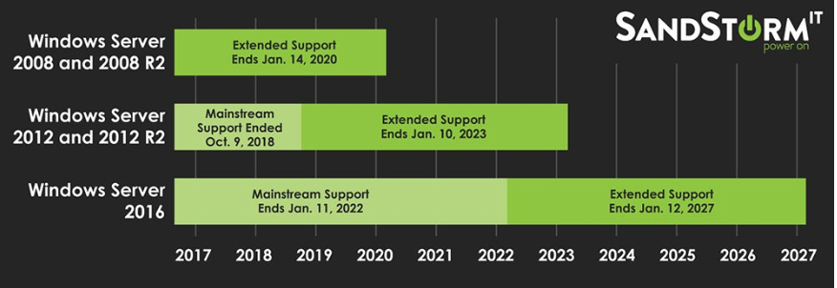Earlier back in June 2019, it was announced that Windows Server 2008 R2 was declared to be at the end of its life with a deadline for support being cut off on 14/01/2020. At the time, this appeared to most companies and organisations to be time consuming to upgrade servers but this could actually become a much a larger task. It could include a hardware refresh or just generally a lot of work for a server team. Organisations cannot simply update to the latest versions of Windows Servers regularly, but this is a characteristic of what businesses should be planning for in the future. This is not included in standard Microsoft packages like SCCM or Intune. They focus on the machine and mobile monitoring, yet Servers are overlooked. Organisations know to patch but an upgrade from 2008 to 2016 is often overlooked.

Figure 10: Windows Server Timeline: SandStorm: (“Microsoft Intune” 2020)

Figure 10 shows the end of life program created by Microsoft. It begins with 2008 and 2008 R2 ending 2020. 2012 and 2012 R2 extends a further 3 years but the largest support level for 2016 lasts until 2027. Planning an organisation could upgrade from 2008 to 2016. They would have 7 plus years of support but again that would place them back in the same situation where no major update to the Windows Server (“Windows Server 2016: A Cheat Sheet - TechRepublic” 2020).

## 5.16.1 Linux

A Linux operating system is like a Windows-based version except does not have a graphical interface for the admins to use. Often used for desktops or for teaching commands to learning users. Linux creates the opportunity for “enhanced permissions, increased flexibility, and stability”. (“Choose a Device Management Solution - Configuration Manager | Microsoft Docs” 2020)

## 5.16.2 Debian and Ubuntu

Debian is a Linux system that allows for software development, and the system is for non-profit. Debian is an operating system that uses a model that is consistent at release. There are three major types of updates: stable, testing and unstable. Stable leads to almost solid infrastructure and a lack of bugs. It is usually an older model. This model works for Server as they aren’t regularly updated but desktop and laptop updates are critical to the key success of the business. Testing is more open for new features and changes. Unstable is the latest version and currently in development. (“Method and System for Processing Functionality of a Configuration Manager Computer Association Tool to an Operating System Deployment Computer Association Process - OPEN INVENTION NETWORK LLC” 2020). Debian is best suited for an enterprise environment due to it being more stable and secure than Ubuntu. (“Microsoft Windows Intune versus System Center Configuration Manager | Communication Square LLC” 2020)

Ubuntu is a user-friendly and creates the appearance of corporate. Ubuntu has regular updates and changes to the model. A new version of the operating system is released every 6 months, after 5 releases it becomes a legacy and is supported for 5 years. Each release is made for Servers and workstations. Although the continuous updates are installed more commonly on the workstations, rather than patching servers every 6 months. Ubuntu uses PPAs/Personal Package Archive which are software repositories that allow for features to be added. Debian does not support this. (“[SOLVED] SCCM or Intune? - Microsoft Intune - Spiceworks” 2020). If the most important features in the deployment server are being on top of releases and software, Ubuntu is the most practical. (“Microsoft Intune” 2020)

# Design of Raspberry Pi

This section of the report will discuss the overall design of the project. It will demonstrate the design principles in the various project sprints to meet the performance milestones. Raspberry Pi 4 was chosen as the specific type of device to create the PXE Server as it produces a higher resolution graphics, CPU, modern display configurations along with offering RAM in 1GB, 2GB and 4GB. These types of devices have better heat management ventilation therefore installing a case that uses this to its advantage means the device can cope with extremely intensively heavy tasks. When creating a test case for the different sizes of deployments.

They should be configured as:

* Small-Medium – Installation of Python
* Large – VMs

## Design Diagram

When considering the design of the Raspberry Pi GUI screen, the primary focus was to make it easy to follow. Black and white to provide a basic structure and colour scheme. The product does not need to be decorative, it’s focus is providing functionality. The design is clear and crisp.

Within the Raspberry Pi itself, it has an attached screen. This connects via the GPIO chipset on the Raspberry Pi 4. The screen is specially configured for the type of the Raspberry Pi by the means of software and physical hardware. The wireframe shows the setup to that is configured on the device. On turning on the device, the user is presented with a login screen. The user is provided with the option to login or register as a new user. If this was connected to an existing deployment system, such as SCCM. This would be connected to active directory, which would force users to login as they would to a machine on the network. Due to the limiting factors for with Microsoft. This would not be possible to implement at this time. Alternatively, they would login as normal.

Once logged in, dependent on the user access three possible options may appear. If the user is a non-technical user, they will only have the user option to launch. If the user is a junior admin, they have access to both user and junior admin sections. The full global admin has access to everything. Each level of privilege has different abilities within the environment

* User
  + They can only see the software being deployed and the instructions on how to do this
* Junior Admin
  + All features of User
  + Select ISO – Pick pre-set ISO included within the device
  + Select OS – x64 or x86
  + Manage Devices – Ability to remove devices that are no longer required
* Global Admin
  + All features of Junior Admin
  + Customise ISO – Customise the steps on ISO creation
  + Customise configuration
  + Add a new device – Customisation to add a new device

After configurations have been finalised, the final screen to the user will appear detailing information the user has to do to launch the machine. The machine will reboot after it’s finished installing.

The backend system is comprised of a Linux Server that creates the ISO file, builds image and configures it for use for the machine. The design of Linux is very simplistic. It uses the full build of the operating systems.

The network topology discussed early in the report was suited to a larger setup for multiple devices using technology such as SCCM. The setup below outlines a realistic setup for the project. Within a home environment where the project will be primarily developed, the home router will pass an internet connection to a Raspberry Pi Server which in turn will the Raspberry Pi’s Clients.

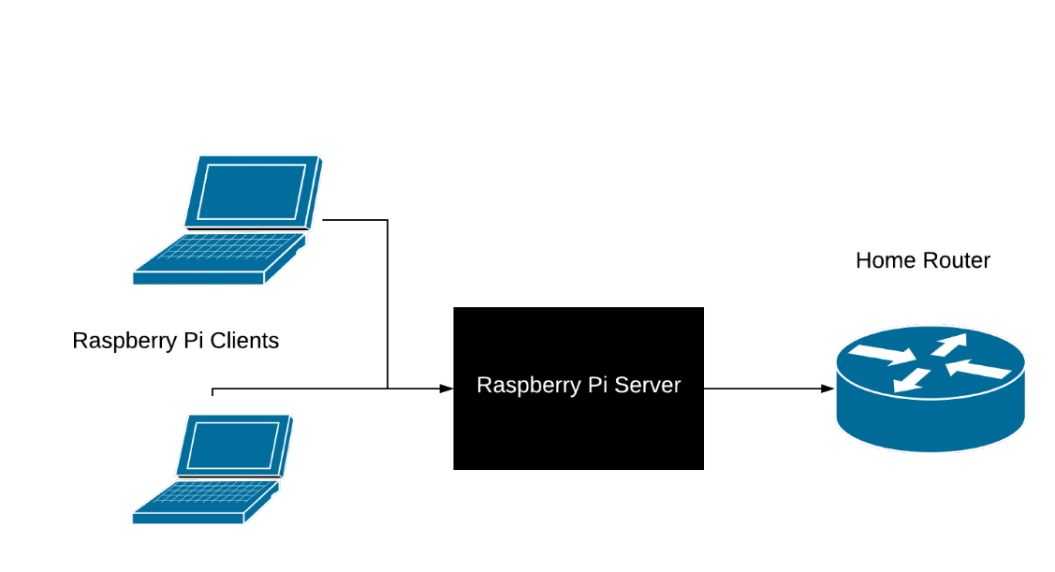

[Figure 11 – Adapted Network Topology]

## Conceptual Design

The conceptual design above shows the very basic outline of what the GUI screen on the server will look like and detail the functionality it will provide. One main screen for a login and selection of user and the appropriate screen. Finally, the launch page to start the process.

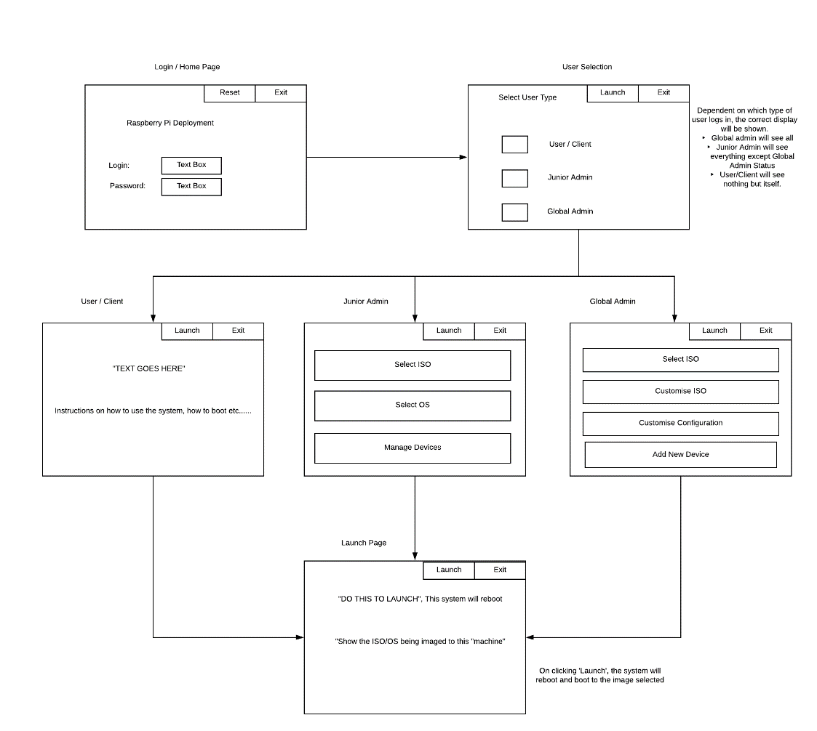

[Figure 12 – Conceptual Design]

# Implementation of the Raspberry Pi

### Pre-installation

At the beginning of researching the implementation of Microsoft tools I began looking to undertake in 60-90-day trials. This was based upon books such as MDM: Fundamentals, Security and Modern Desktop and Microsoft forums. These were under the condition of having Microsoft O365 License. Once attempting to sign up for these, I was unable to do so. After contacting Microsoft to determine if this was possible. I was informed of as I was not a part of a company this would not be possible. I reached out to the University Computing and general resources for assistance to determine if they would help me reach this project. They decided not to proceed with my original project as it went against guidelines and confidentiality. Therefore, my current project was not viable. Although the IT Services offered to guide me in a Horizon View setup. Due to coronavirus, I have decided against going through with this process as it would require being onsite.

Instead, I came up with another form of deployment. A Raspberry Pi acting as a deployment server using DHCP and PXE to redistribute dynamically IP addresses across the network. The PXE element will allow the ‘client’ machine to communicate with the ‘server’ machine.

### Installation

At the beginning of January, I ran into many issues with finding the correct ISO to install on the Raspberry Pi. Trying variations of Linux Mint and Ubuntu but I ultimately chose Raspbian Buster. The Raspberry Pi was struggling to use the configuration types. This was unusual as these types of images should instantly work within the Pi. I decided not to use Noobs, this contains Raspbian and LibreELEC. It can be considered an easier installation due to the less space it requires. But, it was not compatible with setting up a DHCP. After factory resetting the device and using another SD Card, I was successfully able to have a working Raspberry Pi. To create the bootable image onto SD Card I used ‘balenaEtcher’. This allows you to select the image, selecting the target and flashing the SD card. This takes around 20-30 minutes dependent on size. This is how I resorted to backups.

After successfully doing a task, I took a backup by launching ‘Win32 Disk Imager 1.0’, selecting the file location the backup would be saved to and the SD card. This location was my C: drive as I could not integrate to Github due to lack of space.

#### Security and Firewall

I added core security features such as setting and changing passwords for activities that would require additional privileges, applied latest patches and updates, created firewall and set it to allow SSH to enable remote access due to limited physical hardware. This allowed me to login without connecting to a screen. Within the firewall I set a limit to only accept specific IP addresses (only home network) and restricted login attempts to six within thirty seconds. At this point, I took an entire backup on the SD Card as a starting point. Once the Pi was set up, I took backups and stored in primary and secondary locations. I continued to do this across the entire project.

#### PXE and DHCP

Once setting up the Pi with all the correct settings and security features. I began working on a DHCP Server working. DHCP is a service that automatically provides IP address and responds to queries by clients. To do this, I installed dnsmasq which is a DHCP proxy that uses a pre-existing network setup. In this case, this would be my home router. The instructions (“Raspberry Pi PXE Server” 2020) gave detailed steps up until a point where the ‘bootable’ file was being created on the DHCP Server using TFTP Server. I continued to try different methods of doing so, including different versions. I tried sending several different files across instead of the .ISO files to test if it was a large file being sent across the network or low bandwidth issue. I tried switching to SSH. I swapped the hardware to an earlier model (Raspberry Pi 3B). Again, I had issues with getting the basic ISO to work. I also had tried different type of devices being booted to: Windows 10 Laptop, Windows 8 Laptop, Raspberry 3 and Raspberry 4. Latterly, I found out the earlier model of the Pi itself was broken. The issue continued to be reoccurred.

Whilst researching PXE and DHCP Servers, I came across an article stating configuration issues within Raspberry Pi 4 as they are still in the testing phase with the device. The Raspberry Pi 4 is quite new and therefore bugs can be common. I found a website that contains a beta fix. The only drawback was the ‘server’ being a Raspberry Pi 4 can only boot to a ‘client’ that is also a Raspberry Pi 4. I was able to borrow a device from a friend for the duration of the project. The client does not use the SD Card. The Server pre-configured with the last 9 digits of the client’s serial number. The ISO file launches from NFS Folder located on the server (“Network Booting The Pi 4 | Hackaday” 2020). The PXE Server was configured and successfully tested and managed to boot to the ‘client’ machine. On 24th March, the university was closed due to Coronavirus. This meant physical meetings were cancelled. Supervisor meetings were moved to an online system. Physical hardware problems were difficult to diagnose. The project became challenging.

#### Graphical User Interface

Once the Raspberry Pi screen arrived I worked on the functionality of the touchscreen and understanding of how the components work together. Setout a task to try including sizing within the deployment server. Small installation would be something as simple as the installation of python. On the opposite scale, a large installation would be installing an operating system.

After a few weeks, I had a successful running python program running on the Linux system which took lots of configuration to run. The Raspbian image would not run the latest version of python therefore I had to reduce it down a few versions. The access controls just within the python setup were displaying the correct options. The user should only have the option to deploy straight away with no configuration. The junior developer can select OS and ISO and global admin can add devices and all tasks the other users can complete.

#### Poster

I started working on the poster. This would have been shown at the end of the year show. Instead, I recovered a video showing the functionality of the Raspberry Pi’s.

#### Integrating GUI and PXE Server

The Raspberry Pi was able to boot using a pre-set ISO. After leaving the project for two weeks. The Raspberry Pi was unable to boot as it had previously done. This involved taking a previous snapshot and restoring the services. This is a great way of confirming that backups are essential to an application and project like this. The backups are primarily stored on my laptop. Secondary on my RGU OneDrive. Github was not an option as the files are too large to be uploaded. Each SD card totals 30GB.

After getting the Raspberry Pi to a successful working place, I began working on being able to produce different working images. This was done with Raspbian Full and Raspbian Lite. Whilst undertaking this, I discovered a large issue of the available space on the Raspberry Pi was filling up rather fast. Once downloading and extracting the files to the desired location, the download would be deleted. All unnecessary software was removed from the server itself. This allowed for successful alternative ISO to be pushed to the client. To add this functionality to my GUI screen, I created two scripts unique to their folder location to allow the client to communicate with the server. Within the python program, these scripts were linked so on click would begin the desired result. Adapting this I added a network performance tests to be sent to a text file based on the server to show the network utilisation. The poster and demo were submitted.

### Testing

After testing several times between the two images. Ensuring they work independently from a reset device. Alternatively, I installed the other version on top of the other, confirming this was overwriting the contents. This confirmed the requirement of being able to boot from multiple images/ISOs. This was integrated within the GUI with the register/login pages. The user was able to boot the single standard image. Both junior and global admin were able to boot either. I moved onto more extensive testing covered in the next section.

# Testing and Results

### 8.1 Requirements Testing

To test the functionality of the project, I had planned to do it in three stages. Testing within the home environment to reach the project’s functional and non-functional requirements along with accurately meeting the test scenarios. Once these goals have been reached, the testing would have been carried across to a non-technical and technical person to carry out a deployment using the screen as instructions and finally a remote deployment in a new location. This cannot be carried out due to social distancing. Therefore, the best test I can do is ask a technical person to test the deployment method and gather his response.

Testing Template: 0 – Example

|  |  |
| --- | --- |
| Test Number | 0 |
| Test Description | TEXT |
| Expected Result | TEXT |
| Actual Result | TEXT |

Test Cases:

1. Raspberry Pi loads Pi Screen
2. PXE Installs ISO
3. PXE Server shows multiple options for selections
4. Raspberry Pi can boot physical machine with ISO
5. Selection choice on Raspberry Pi screen for the target machine has a multi-choice box that allows a custom-built image created
6. Selection choice on Raspberry Pi Screen for target machine has a custom built-in core image for the machine
7. A technical person is given the Raspberry Pi to boot and build the machine. Tests machine for basic functionality from the given list
8. Non- technical person is given the Raspberry Pi to boot and build the machine. Tests for basic functionality from a given list - Cannot be done, coronavirus
9. Perform a deployment in a remote location – Cannot be done, coronavirus

### Test Cases - Tables

|  |  |  |  |
| --- | --- | --- | --- |
| Number | Test Description | Test Case Number | Pass/Fail |
| 1 | Load Screen on Pi | 1 | Pass |
| 2 | PXE Server installs ISO | 2 | Pass |
| 3 | PXE Server shows multi options | 3 | Pass |
| 4 | Raspberry Pi can boot to Device | 4 | Pass |
| 5 | Selection with multi-choice, custom screen | 5 | Pass |
| 6 | Custom-built core image | 6 | Fail |
| 7 | Technical Implementation | 7 | Pass |
| 8 | Non-Technical Implementation | 8 | Pass |
| 9 | Remote Location | 9 | N/A |

### Test Cases - Tables

|  |  |
| --- | --- |
| Test Number | 1 |
| Test Description | Loads Screen on Pi |
| Expected Result | Screen Boots up |
| Actual Result | As Expected. Can be seen in Demo. |

|  |  |
| --- | --- |
| Test Number | 2 |
| Test Description | PXE Server installs ISO |
| Expected Result | PXE Server will communicate with client and boot with the selected ISO |
| Actual Result | As Expected. Can be seen from Proof of Concept. |

|  |  |
| --- | --- |
| Test Number | 4 |
| Test Description | Raspberry Pi can boot to Device |
| Expected Result | PXE Server will communicate with client and boot with client |
| Actual Result | As expected. Can be seen in the demo. |

|  |  |
| --- | --- |
| Test Number | 3 |
| Test Description | PXE Server shows multi options |
| Expected Result | Raspbian Lite and Raspbian Full show as options on the GUI screen |
| Actual Result | As expected. Can be seen in the demo. |

|  |  |
| --- | --- |
| Test Number | 5 |
| Test Description | Selection with multi-choice, custom screen |
| Expected Result | The Raspberry Pi Server shows multiple options for users and ISO files. The user can navigate on their choices |
| Actual Result | As expected, see the demo. |

|  |  |
| --- | --- |
| Test Number | 6 |
| Test Description | Custom-built core image |
| Expected Result | The global admin can create a custom-built image from the screen itself. |
| Actual Result | Fail – Test Failed because there is not enough space on the device to enable this. |

|  |  |
| --- | --- |
| Test Number | 7 |
| Test Description | Technical Implementation – A technical user can review and implement a deployment |
| Expected Result | Technical user can understand the procedure and follow it exactly |
| Actual Result | As expected. Tested on a fellow Computer Science student in lockdown. |

|  |  |
| --- | --- |
| Test Number | 8 |
| Test Description | Non-Technical Implementation – A non-technical user can review and implement a deployment |
| Expected Result | A non-technical user can understand the procedure and follow it exactly |
| Actual Result | As expected. Tested on with friends via Video Conferencing Tool. |

|  |  |
| --- | --- |
| Test Number | 9 |
| Test Description | Remote Location – Able to produce a working deployment within a remote location |
| Expected Result | The deployment should work in a remote location |
| Actual Result | Cannot be tested as in lockdown. |

### 8.2 Questionnaire

In an approach to understand if this project assists a user in how to deploy an image. I created a questionnaire and sent it to a variety of friends and colleagues to gather an idea of their understanding. The purpose of the questionnaire was to check the deployment server firstly made sense to a non-technical group of people. These people are based in a variety of industries and different stages of life. The questionnaire contains a video linking to a folder within my personal RGU OneDrive. This was the easiest way as the file was too large to upload to SurveyMonkey. This turned out only to work with RGU students. Anyone who was not an RGU student was sent the video via social media to ensure the questionnaire was completed correctly. The video showed how the GUI functioned.

Firstly, I asked the users to confirm they watched the video. Out of 11 voters, 11/11 voted they had. This confirms they have seen the content and are able to answer the questions. Secondly, to gather a basic understanding, I asked the users to establish if they had setup a new device. This could have been something very simple such as setting up an iPad to a new Windows machine. Even when setting up a device so simple as an iPad, there is a register and login with customisation of their experience and personal tastes. This also gets the user thinking of how previous experiences compared the video were. If this test could be carried in person with a full demonstration would have been idea but circumstances change. Therefore, this test plan has been adapted to accommodate the change.

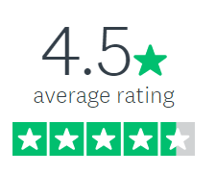The next question was to establish how much of the video was understood. The average score was 4.5. This is definitely at the highest end of the scale. This is excellent to see as it shows the video was simple and easy. The instructions on the Raspberry Pi were understood well. The lowest score was average. This again is excellent. The average weighted score comes out at 3.0.

100% of the users voted ‘yes’ to being able to follow the instructions on the screen. 11/11 voters. This could be considered as making it easier. Often people expressed trouble in setting up a new device. Both in a professional and personal setting.

When asking what would make the progress easier, the results varied with a consistent theme of the device is missing colour. The black and white is challenging to view. Add coloured to differentiate the options available. Another suggestion was using a menu rather than the graphical form. And finally, a voiceover showing the functionality. This would have been addressed if this was an in-person test.

Finally, the voter was asked if they had any other feedback for the project. All comments were very positive to the project. A few voters commented on how excellent when this would be and how much they love to have it in their own industry. ‘Good project - useful in industry’. This confirms the fact to be that this project could be valued to a futuristic business environment.

Link to Questionnaire: <https://www.surveymonkey.co.uk/r/V99FXM3>

Link to Dashboard of Results: <https://www.surveymonkey.com/results/SM-J2YSZ2TN7/>

### 8.3 Test Evaluation

The results from the requirements test cases are as expected, all except the remote location. I have explained the issues with the wired connection previously. If that was not the case, I believe a test would have been successful in testing the remote connectivity. If this test was successful, this would have fulfilled the requirement of a no network deployment. The questionnaire feedback has come back heavily positive towards the device. The users understood the video and would be able to produce the result following the detailed instructions.

# Evaluation

The aim of the project was to investigate deployment tools to determine which have futuristic values and requirements for a business. During this project, I have evaluated how deployment tools such as SCCM, Intune and SmartDeploy operate and gather information and their advantages/disadvantages. But more importantly, I have proposed the question: does this technique provide modern technology the innovations that will bring businesses into the next digital age? I believe the smaller businesses such as Smart Deploy will be eaten by the larger fish in the market. SCCM and Intune will continue to grab market share of all stages of the business. The smaller companies will set money aside to pay for the giants. The objectives of the project were extensive and well documented.

Objective 1 was to investigate and comparing the core features and tools of the deployment tools. This was completed by researching the different type of tools available to businesses. Researching what services, the tools use and how they manipulate the client into managing the services.

Objective 2 was to research the implementation of Servers and Virtual Machines and “Client” machines. This object was not met fully. The use of virtual machines was not implemented. After researching the into implementing a Microsoft based tool. This was unable to be implemented due to restrictions. But I believe if I had been given access, I believe this project could have been brought further and the idea of determining the futuristic element could have been brought fully to life. Although these tools are popular they have flaws. They are difficult to setup without being in a particular environment and they do not allow for young inexperienced developers to experiment with the tool. They are also not easy to implement. My project resolved both of these issues: it provides the basic concept of what a deployment server is and understanding the ideology of what it provides.

Objective 3 was to research implementation of the chosen delivery tool. Throughout searching for the requirements for a Raspberry Pi as a deployment server, I discovered similar projects. These projects were all implementing the PXE/DHCP service as a standalone service, but a standard user would never be able to repeat this.

Therefore, I began searching for common interfaces that are easy to understand. To understand what makes something easy to understand. To prepare for the implementation, I began reviewing different type of devices and considerations for type of operating systems this should be created. I chose a Raspberry Pi 4 because of the faster processing speed, bigger RAM and much greater storage. The entire specification was perfect for the project as a standard Raspberry Pi would be too slow to undertake the processing element.

Objective 4 focussed on researching on how to implement core-image and software files. This objective was met by in-depth searching into the DHCP and DNS technologies, to gain a better understanding on how to fully implement these. Throughout the project, there has been a side focus on how I can improve stability or suggest better practises for server management. Objectives 5 aimed to implement network infrastructure (Servers/VM’s). This was met within objective 4.

Objective 6 Implemented core features & security tools such as password policy. If the project had been a Microsoft tool based, this section would have been much larger as they both offer much more sophisticated and well-developed features. Within the Raspberry Pi, I added the core firewall. Restricting access to access within the home network only. Enabling SSH to allow for remote access. Changing the standard password to a more complex password to ensure standards.

Objective 7 and 8 is based on the testing phase. Using test users to implement software delivery using user trials to evaluate what had been produced so far and what improvements could be added. Unfortunately, the user tests were unable to happen due to restrictions, but I believe they would have shown early positive results towards the project. In hindsight it would have been good to receive comments on the appearance as this could have been easily changed. Objective 8 has been met writing this report, to evaluate the tool developed.

This project has faced a variety of legal, social, ethical, professional and security issues. The main consequence is data protection of their register and login. From a legal stance, holding the user’s information stored as an account. Although this is stored within the file structure on the server, this could be considered as secure and if an attack took place on a system alike this, the entire system would be compromised anyway. This device wouldn’t ideally be networked instead acting as a standalone device. The server wipes any contents when the new operating system is loaded on. This minimises the possibility of the contents being accessed by authorised parties. The project did not implement any security policies as this again would have been a Microsoft service.

Test subjects would have been using their data to sign up for accounts. Instead, I have created sample accounts with randomised information. Within the SurveyMonkey survey, the users were made fully aware of what their information was being used for such as providing statistics on usability. This is protecting users under the Data Protection Act 2018. Their information has been protected lawfully, correctly and securely. Their data will be deleted from SurveyMonkey and elsewhere after this project concludes. At any point, they have been able to access, edit and be deleted. The project also followed GDPR guidelines on storing data and how it is used.

From a security stance, the software and operating system has been kept up to date with the latest information. This reduces the change of the data leak or potential attack. Firewalls were setup on all devices and Anti-Virus on networked machines.

The project does provide the basic functionality of a deployment server. But, it is unable to boot to devices other than Raspberry 4. This would be the next step in making this a fully-fledged deployment server, including Windows and Mac devices would create an multi image and multi device server, this would be a vast improvement. Adding colour into the GUI will make it more user friendly and approachable. Adding a setting page to allow the user to manipulate the setup into how they would like it eg different fonts and sizing.

# Conclusion

In conclusion, the project as a whole has been successful. It meets majority of the requirements set out during the literature review and the requirements analysis. The deployment server is successfully able to boot multiple images. It produces a register and login page for the user to sign up if not already a type of user. The type of user is connected to the security measures of the system. In the desired setup, an offline version of LDAP or Active Directory would be best. The process successfully walks the user through the processes required and is clear around what is required by the user.

The original project incorporated SCCM and Intune as the main focus. This was later discovered as impossible to produce. If the situation has been different, this project would have been entirely different. I believe it would have given me a greater understanding of modern-day deployment. But producing my setup has given me first-hand knowledge of how all the elements interact with each other. I still believe SCCM and Intune are impressive and well-established tools. They will continue to set the standard across the industry in a Microsoft dominated field.

Throughout this process, I have learnt a great amount about DHCP and DNS servers. Along with the basics of deployments. I hope to use this in the future. I was unable to tackle the gigantic task of improving the lack of attention towards server management as the project focused on the deployment server and the GUI screen. A smarter way of restoring and producing backups in challenging circumstances would require further research and development within VMWare.

# Appendix

## 11.1 Links

Link to GitHub for python backups of files, ISO will not be stored here (public): <https://github.com/kirstyforrest/Honours-Project/>

Link to RGU OneDrive (location of ISO files): <https://liverguac-my.sharepoint.com/:f:/g/personal/1501752_rgu_ac_uk/EpXTkRaCsXtPmWk8PED_E9YBhrYjpZf-_7w5M2muuS9dmg?e=khRQzU>

Link to Asana for project updates and progress tracker (Closed Project, both myself and Andrei are admin, therefore, anyone can be added at any time): <https://app.asana.com/0/1142273549119410/board>

Link to Questionnaire: <https://www.surveymonkey.co.uk/r/V99FXM3>

Link to Dashboard of Results: <https://www.surveymonkey.com/results/SM-J2YSZ2TN7/>

## 11.2 Project Proposal

## Project Title

An Investigation into software deployment tools to determine the futuristic requirements for small-medium business standards.

## Background

The project is an investigation of major software and operating system deployment tools. During the investigation, I will understand which one the future of deployments in a business environment is. I will identify the critical features that are key to implementing and managing a business. The features will include password policy. This project will involve implementing multiple VM’s (Server and Clients) and managing the environment.

This project is key to establishing a question that is becoming more and more asked. Has Intune become more popular than SCCM? Is there any upcoming deployment tools? It has been debated at Microsoft conferences and forum’s online. The simple answer is, SCCM is aimed at a large client base and inTune at a smaller basis. Yet SCCM has a greater power of features and stronger client basis (“Choose a Device Management Solution - Configuration Manager | Microsoft Docs” 2020)

Previously, SCCM and Intune have been used side by side to complement each other’s features but recently this has been a move to solely implement an Intune as a sole feature. “if you're running all Windows 10, then Intune isn't bad to explore as your only tool, just since SCCM is such a bear to install and configure and maintain” (“Method and System for Processing Functionality of a Configuration Manager Computer Association Tool to an Operating System Deployment Computer Association Process - OPEN INVENTION NETWORK LLC” 2020). This statement above is declaring that Intune is great for a sole Windows 10 system. This is true of most systems today as the time is ticking on support for Windows 7 expiring in January 2020. All/most IT-based system who would be implementing this system would be on Windows 10 now or will be soon.

According to the Microsoft website detailing their functionality, the list contains details about their mobile device management implementation system which applies to all different platforms: Windows, macOS, iOS and Android. They also provide functionality with the cloud and implementing scalable services to ensure their client's businesses are current (“Method and System for Processing Functionality of a Configuration Manager Computer Association Tool to an Operating System Deployment Computer Association Process - OPEN INVENTION NETWORK LLC” 2020)

System Centre Configuration Manager is the largest deployment strategy that Microsoft manage and own. They can mix and match the solution to fit the client’s needs. The model requires management software installed on PC’s, Servers and other devices. There is functionality to implement Intune along with their other features (“Choose a Device Management Solution - Configuration Manager | Microsoft Docs” 2020). Imaging/reimaging using SCCM is deployed by ethernet. “Boot from a Network Interface Card (NIC) that has an associated MAC address, using the PXE, wherein the PXE boot process then hands the operation over to the designated OSD Task Sequencer (TS) which handles the configuration process according to at least one variable”. The system uses PXE boot to boot into the imaging process (“Method and System for Processing Functionality of a Configuration Manager Computer Association Tool to an Operating System Deployment Computer Association Process - OPEN INVENTION NETWORK LLC” 2020). This is one of their critical and essential features.

## Motivation

I will be researching and implementing a deployment tool to determine the key features and possible tools that tie into the package and which model is futuristic for businesses. The information in this project will assist the key business to make an efficient and clever solution to fit their business’s needs. They would benefit from cost savings and understand critical features which may be important to their business. By company, it does not refer to a specific as it is helpful to numerous companies such as companies transitioning to a separate entity or merging etc.

## Aims and Objectives

Aim: Investigate a deployment delivery tool to decide on the most efficient for the futuristic business model to deploy their End User Computing needs.

* Objective 1: Investigating and comparing the core features, tools and admin services of the deployment tool.
* Objective 2: Research the implementation of Servers and Virtual Machines and “Client” machines.
* Objective 3: Research implementation of the chosen delivery tool.
* Objective 4: Research on how to implement core-image and software files.
* Objectives 5: Implement network infrastructure (Servers/VM’s).
* Objective 6: Implement Core Features & Security Tools such as password policy.
* Objective 7: Use test users to implement software delivery using user trials.
* Objective 8: Implement feedback from test-user.
* Objective 9: Evaluate the delivery tool.

## Legal, Social, Ethical, Professional and Security Issues

* Legal – Personal from fake accounts for testing and demonstration purposes
* Security – Implementing security policies could cause issues and harm to users.
* Ethic – Responsibility for all content placed on machines and It is the
* Social – Using user data for Survey Results
* Security – Protecting users who provide information into by the Data Protection Act 2018.
* Security – Installing latest versions of software and operating systems
* Security – Firewall and Anti-Virus software will be installed
* Security – Maintaining EU’s General Data Protection Regulation

## Project Plan

* Objective 1: Investigating and comparing the core features, tools and admin services of the deployment tool.
  + Identify deployment tools and what services they provide.
  + Compare these tools for positives and negatives and similarity
* Objective 2: Research the implementation of Servers and Virtual Machines and “Client” machines.
  + Investigate how a Server is implemented and what software tools are required for each server (Microsoft tools, firewall, client management). What is the requirement of hardware?
  + Investigate Virtual Machines combines the server and how to implement the client-facing side and what hardware requirements are needed for this to be implemented
  + Investigate “Client” is now implemented and what hardware is required
* Objective 3: Research implementation of the chosen delivery tool.
  + Researching the implementation strategies of the most futuristic tool.
  + How I install the tool and what hardware is needed and how many VM’s are required.
* Objective 4: Research on how to implement core-image and software files.
  + Research the basic Microsoft Core Application image and add additional software to this.
* Objectives 5: Implement network infrastructure (Servers/VM’s).
  + Implement Servers, Clients and VM’s required
* Objective 6: Implement Software Delivery (Core Features & Security Tools such as password policy).
  + Implement the software delivery
  + Implement the core features of client machines
  + Implement Policy’s
* Objective 7: Use test users to implement software delivery using user trials.
  + Test with testing VM’s and possibly physical machines with test users/fake accounts
* Objective 8: Implement feedback from test-user.
  + Implement the feedback given by test users/fake test accounts based on the tool feedback
* Objective 9: Evaluate the delivery tool.
  + Evaluate the information from the deployment and test cases.
  + Comparison of findings to other tools from Sources

## 11.3 Poster

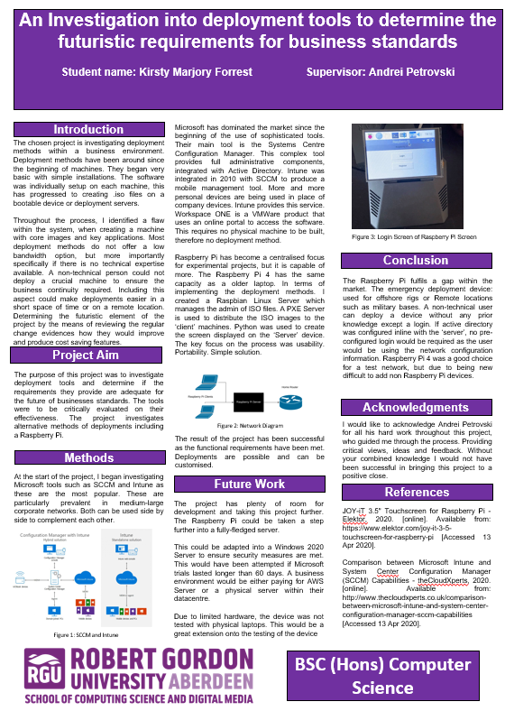

[Figure 13]

## 11.4 Demo Screenshots

The screenshot below shows the python script working on the device. This is also available from the start-up of the screen.

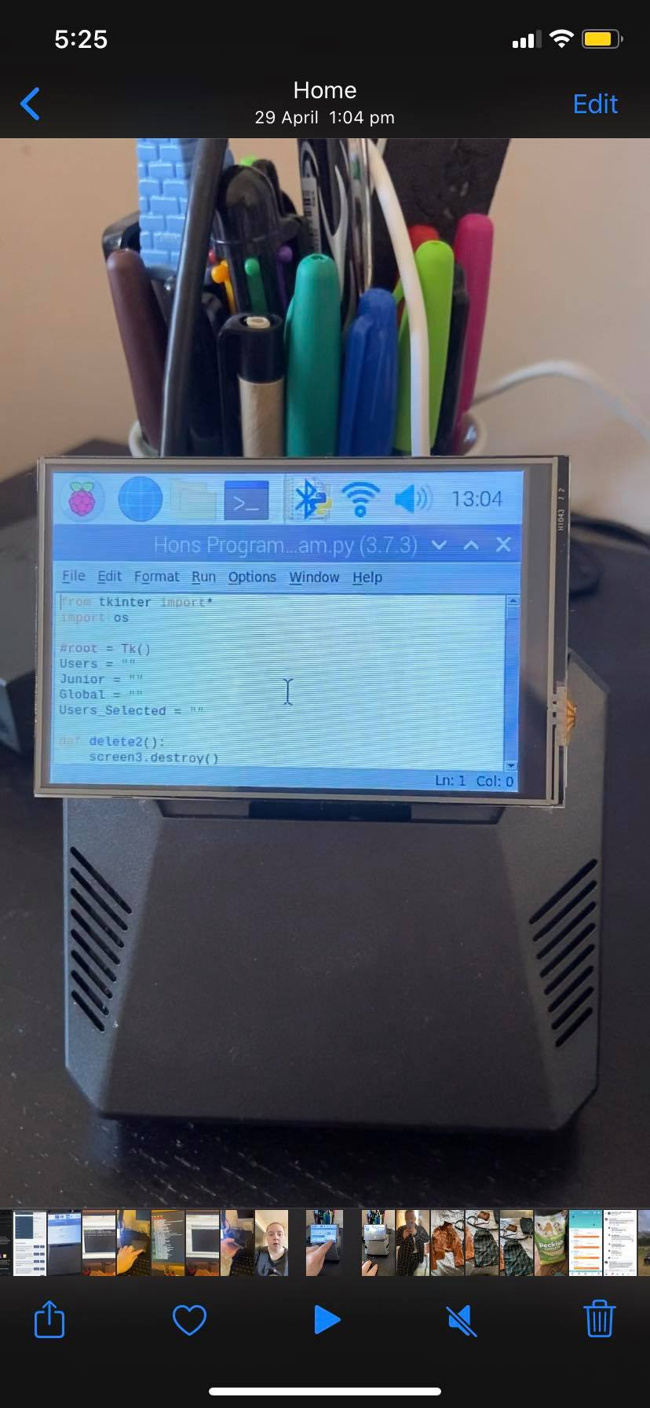

The screenshot below shows the register page and the details expected of the user to fill in

The screenshot below shows a successful registration

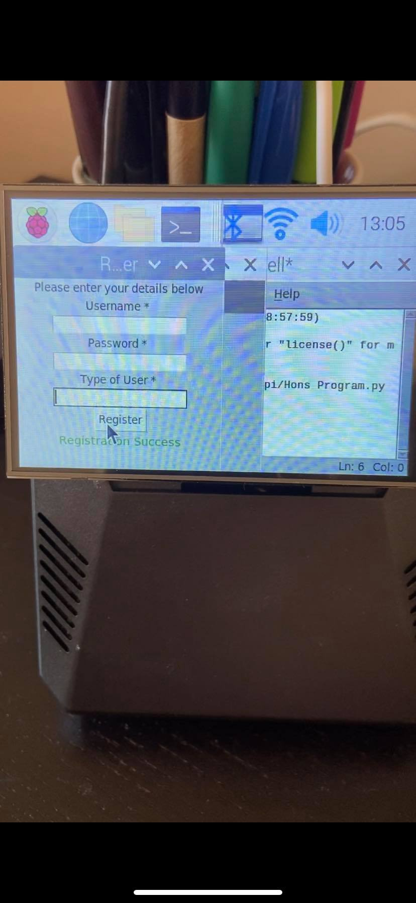

The screenshot below shows a user login in. Given more time, the password field would be hashed.

Screenshot showing the home screen for a global admin

Screenshot showing outline of the ‘Users’ page

Screenshot showing the ‘Junior Admin’ page

The screenshot shows the ‘Global Admin’ page

Screenshot showing the deployment page for all users. Click launch starts the script.

Screenshot showing the Raspbian Buster Image and process it follows to install

## 11.4 Abbreviations

PXE – Preboot Environment

DHCP – Dynamic Host Configuration Protocol

ISO – Network standard for a type of image file

NFS – Network File System

IP – Internet Protocol

TFTP – Trivial File Transfer Protocol

SSH – Secure Shell

## 11.5 Source Code

The python file for the GUI will be attached in the additional Dropbox. The ISO source code can be found on RGU OneDrive: <https://liverguac-my.sharepoint.com/:f:/g/personal/1501752_rgu_ac_uk/ErxZSw6UEhlGjiP3ralCsdQBbxpcMVrV4mX8zOMyTY81dA?e=DVxcjS>

## 11.6 Test Plans

The test plans can be found in the additional Dropbox

## 11.7 Project Log

The project log can be found in the additional Dropbox (Export of Tasks 16052020.xlsx).

## 11.8 Ethics Policy Application

**STUDENT PROJECT ETHICAL REVIEW (SPER) FORM**

**The aim of the University’s *Research Ethics Policy* is to establish and promote good ethical practice in the conduct of academic research. The questionnaire is intended to enable researchers to undertake an initial self-assessment of ethical issues in their research. Ethical conduct is not primarily a matter of following fixed rules; it depends on researchers developing a considered, flexible and thoughtful practice.**

**The questionnaire aims to engage researchers discursively with the ethical dimensions of their work and potential ethical issues, and the main focus of any subsequent review is not to ‘approve’ or ‘disapprove’ of a project but to make sure that this process has taken place.**

The *Research Ethics Policy* is available at  [www.intranet.rgu.ac.uk/credo/staff/page.cfm?pge=706](http://www.intranet.rgu.ac.uk/credo/staff/page.cfm?pge=7060)0

|  |  |
| --- | --- |
| **Student Name** | Kirsty Marjory Forrest |
| **Supervisor** | Andrei Petrovski |
| **Project Title** | An Investigation into software deployment tools to determine the futuristic requirements for business standards. |
| **Course of Study** | BSc Computer Science with Placement |
| **School/Department** | CSDM |

|  |  |  |  |
| --- | --- | --- | --- |
| **Part 1: Descriptive Questions** | | | |
| 1 | Does the research involve, or does the information in the research relate to: | Yes | No |
|  | (a) individual human subjects | x |  |
| (b) groups (e.g. families, communities, crowds) |  | x |
| (c) organisations | x |  |
| (d) animals? |  | x |
| Please provide further details: | | |
|  | Testing with people for deployment purposes, gathering basic information/software requirements/Operating System.  Possibility to contact organisations to gather real-life data on critical and key features of their businesses |  |  |
| 2 | Will the research deal with information which is private or confidential? | Yes | No |
|  | x |  |
| Please provide further details: | | |
| Personal information from testing/evaluation to create successful tests. Names, DOB, email addresses and password.  Interaction with the system. |  |  |

|  |  |  |  |
| --- | --- | --- | --- |
| Part 2: The Impact of the Research | | | |
| 3 | In the process of doing the research, is there any potential for harm to be done to, or costs to be imposed on | Yes | No |
|  | (a) research participants? |  | X |
| (b) research subjects? |  | x |
| (c) you, as the researcher? | x |  |
| (d) third parties? |  | X |
| Please state what you believe are the implications of the research: | | |
| Cost of deployment tools, Intune/Server deployments are not free products. | | |
| 4 | When the research is complete, could negative consequences follow: | Yes | No |
|  | (a) for research subjects |  | X |
| (b) or elsewhere? |  | X |
| Please state what you believe are the consequences of the research: | | |
|  | | |

|  |  |  |  |
| --- | --- | --- | --- |
| Part 3: Ethical Procedures | | | |
| 5 | Does the research require informed consent or approval from: | Yes | No |
|  | (a) research participants? | X |  |
| (b) research subjects | X |  |
| (c) external bodies |  | X |
| If you answered yes to any of the above, please explain your answer:  Permission will be required for test subjects, this will be requested before any work is carried out. Evaluation users will be warned before completing the questionnaire. | | |
| 6 | Are there reasons why research subjects may need safeguards or protection? | Yes | No |
|  |  | X |
| If you answered yes to the above, please state the reasons and indicate the measures to be |  | X |
| 7 | Has PVG membership status been considered? |  | X |
|  | (a) PVG membership is not required. |  | X |
| (b) PVG membership is required for working with children. |  | X |
| (c) PVG membership is required for working with protected adults. |  | X |
| (d) PVG membership is required for working with both children and protected |  | X |
| If you answered yes to (b), (c) or (d) above, please give details: | | |
| 8 | Are specified procedures or safeguards required for recording, management, or storage of data? | Yes | No |
|  | x |  |
| If you answered yes to the above, please outline the likely undertakings:  Data is being collected for testing on deployment tool.  Storing data will be stored on server/azure, password-controlled, restricted access.  Paper data will be stored on google drive, controlled by passwords/two factors.  Data will be removed when no longer required.  Data can be changed/removed at any time. | | |

|  |  |  |  |
| --- | --- | --- | --- |
| Part 4: The Research Relationship | | | |
| 9 | Does the research require you to give or make undertakings to research participants or subjects about the use of data? | Yes | No |
|  | x |  |
| If you answered yes to the above, please outline the likely undertakings:  Yes, name, email, DOB, password, software requirements | | |
| 10 | Is the research likely to be affected by the relationship with a sponsor, funder or employer? | Yes | No |
|  |  | x |
| If you answered yes to the above, please identify how the research may be affected: | | |

|  |  |  |  |
| --- | --- | --- | --- |
| Part 5: Other Issues | | | |
| 11 | Are there any other ethical issues not covered by this form which you believe you should raise? | Yes | No |
|  |  | x |
|  |  | | |

|  |  |  |  |
| --- | --- | --- | --- |
| Statement by Student  I believe that the information I have given in this form is correct and that I have addressed the ethical issues as fully as possible at this stage. | | | |
| Signature | Kirsty Marjory Forrest | Date | 27.09.2019 |

|  |  |  |  |  |
| --- | --- | --- | --- | --- |
| Part 6: To be completed by the supervisor | | | | |
| 12 | Does the research have potentially negative implications for the University? | | Yes | No |
|  |  | √ |
| If you answered yes to the above, please explain your answer: | | | |
| n/a | | | |
| 13 | Are any potential conflicts of interest likely to arise in the course of the research? | | Yes | No √ |
|  | If you answered yes to the above, please identify the potential conflicts: | | | |
| n/a | | | |
| 14 | Are you satisfied that the student has engaged adequately with the ethical implications of the work? [In signifying agreement, supervisors are accepting part of the ethical responsibility for the project] | | Yes √ | No |
|  | If you answered no to the above, please identify the potential issues: | | | |
| n/a | | | |
| 15 | **Appraisal:** Please select one of the following | | | |
|  | The research project should proceed in its present form – no further action is required | | √ | |
| The research project requires ethical approval by the School Ethics Review Panel | |  | |
| The research project needs to be returned to the student for modification prior to further action | |  | |
| The research project requires ethical review by an external body. If this applies please give details | |  | |
| Title of External Body providing ethical review |  | | |
| Address of External Body |  | | |
| Anticipated date when External Body may consider project |  | | |

|  |  |  |  |
| --- | --- | --- | --- |
| Affirmation by Supervisor | | | |
| **I have read the student’s responses and have discussed ethical issues arising with the student. I can confirm that, to the best of my understanding, the information presented by the student is correct and appropriate to allow an informed judgement on whether further ethical approval is required.** | | | |
| **Signature** | C:\Users\cmsap.RGU\AppData\Local\Microsoft\Windows\INetCache\Content.Word\Signature Small.gif/A. PETROVSKI/ | **Date** | 27 September 2019 |

## References

Web Pages/ Forums

*Choose a device management solution - Configuration Manager | Microsoft Docs*, 2020. [online]. Available from: https://docs.microsoft.com/en-gb/configmgr/core/plan-design/choose-a-device-management-solution [Accessed 2 Apr 2020].

*[SOLVED] SCCM or intune? - Microsoft Intune - Spiceworks*, 2020. [online]. Available from: https://community.spiceworks.com/topic/2168266-sccm-or-intune [Accessed 2 Apr 2020].

*Method and system for processing functionality of a configuration manager computer association tool to an operating system deployment computer association process - OPEN INVENTION NETWORK LLC*, 2020. [online]. Available from: http://www.freepatentsonline.com/10102009.html [Accessed 2 Apr 2020].

*Microsoft Intune*, 2020. [online]. Available from: https://www.microsoft.com/en-gb/microsoft-365/enterprise-mobility-security/microsoft-intune [Accessed 2 Apr 2020].

*Microsoft Windows Intune versus System Center Configuration Manager | Communication Square LLC*, 2020. [online]. Available from: https://www.communicationsquare.com/news/microsoft-windows-intune-vs-system-center-configuration-manager/ [Accessed 2 Apr 2020].

*Network Booting The Pi 4 | Hackaday*, 2020. [online]. Available from: https://hackaday.com/2019/11/11/network-booting-the-pi-4/ [Accessed 14 Apr 2020].

*Raspberry Pi 4 Model B– The Pi Hut*, 2020. [online]. Available from: https://thepihut.com/products/raspberry-pi-4-model-b?variant=20064052740158&src=raspberrypi [Accessed 16 May 2020].

*Raspberry Pi PXE Server*, 2020. [online]. Available from: https://docs.j7k6.org/raspberry-pi-pxe-server/ [Accessed 14 Apr 2020].

*Windows Server 2016: A cheat sheet - TechRepublic*, 2020. [online]. Available from: https://www.techrepublic.com/article/windows-server-2016-the-smart-persons-guide/ [Accessed 10 May 2020].

*Books*

*CORPORATION, M., 2019. Dec2012_Windows_Intune_Getting_Started [ebook]. 1st ed.*